EEM Release Notes

for

Version 3.17 released as of

3/16/2018 1:52 PM

Table of Contents

1. Introduction 3

2. Compatible Products 3

3. Installation Steps 3

4. New Features 3

5. Bug Fixes 4

6. Known Problems and Workarounds 4

1. **Introduction**

This document communicates the major new features, bug fixes and setup changes in this release of the EEM. It also documents known problems and workarounds.

# Compatible Products

This release has been tested on the following platforms and products:

* Windows OS 2012 on the Server
* Windows OS 7.0 on the Client
* MS SQL Server 2012
* Internet Explorer 11

# Installation Steps

* Backup the EEM Production Binaries for future use
* Download the Release rar files from the git hub.
* Stop the EEM Production Website on IIS
* Extract any one rar file which will automatically extract all required EEM binaries and related files.
* After successful extraction, copy the files to the EEM release location on the EEM server.
* Go to the Scripts\Upgrade folder in the released location and run Setup.cmd
* Restart the EEM Production Website on IIS

# New Features

The following new features appear in this release:

*4.1 Feature Description:* Moving all Email configuration in EEM to a single place.

*Details*

* The Email configuration settings used by EEM applications and the SSRS Reporting service have been moved from web config to the database
* This requires you to setup the configuration for the Email function to work properly
* Use the System Preferences screen, System tab to make the required changes
* Please make sure all the values in the fields are provided. Here is a snapshot of the fields

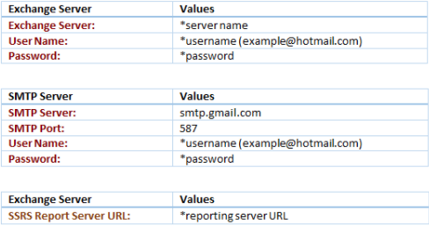

# Bug Fixes

***5.1 Bug Description:*** NFB should not be converted into ICF unless QALs approve (Thru EEM Permission

***Fix***

* A new permission has been introduced in User entitlement ->Request Tracker -> Change type.
* Users who have this permission can only change the task type in edit mode of a Request.
* Make sure the user who should change the task type is given this permission for this fix to work.

***5.2 Bug Description:*** MSM Plan feature enhancements

***Fix***

* The size of the pop-up screen that shows up when you click on the “Status” field of the MSM has been increased for ease of use.

# Known Problems and Workarounds

None